Module 02 - Part 2: Hands-On Project 4-1: SSL Server and Browser Tests
Jadon Kosberg

Steps:
Site api.dropbox.com
4: Grade given A+
5: It received an A+ so few reasons were listed for a bad grade but there were a couple of weak cipher suites in the TLS 1.2 section. It received an A+ because it supports TLS 1.3, It has a secure and trusted certificate. It scored a 100 on Certificate, It scored a 100 on Protocol strength, it scored a 90 on key exchange and a 90 on Cipher Strength.
6: I can tell after looking at the Certificate #1 information that it uses RSA 2048 bit cryptography to encrypt it server key and it has trusted certificates.
7: The list of Protocols supported by this service is TLS 1.3 and TLS 1.2. To increase its security, it would no longer support TLS 1.2 or if a new version of TLS came out it would support that.
8: The cipher suite listed first should be TLS 1.3 since it’s the most recent and most secure version of TLS. In particular the TLS AES 256 GCM SHA384 since it uses the most complex cryptography.
10: The site I picked in recent worst was b2b.ccb.com It received a grade of F and I agree with this. It does not support secure cypher suites, its vulnerable to poodle attacks and it supports insecure protocols. It is an overall insecure website.
11: I searched www.ivytech.edu and it returned a score of A+.
12: I would agree, the site uses TLS 1.3 and it uses HSTS and secure Cipher suites with the most up to date protocols. It also has multiple trusted certificates and use a multitude of cryptography methods.
13: There is not any vulnerabilities with the ivytechs website but I think that making sure you have ssl 2 and ssl 3 disabled and are using tls 1.2 or 1.3 is a must so you can prevent DROWN attacks or POODLE attacks. Make sure you are not using old versions of tls too 1.1 or below. Make sure you use a different block cipher mode. Alos make sure to sure to insert pakcets of length 0 to you can pad block size which helps with insecure IVs.

15:
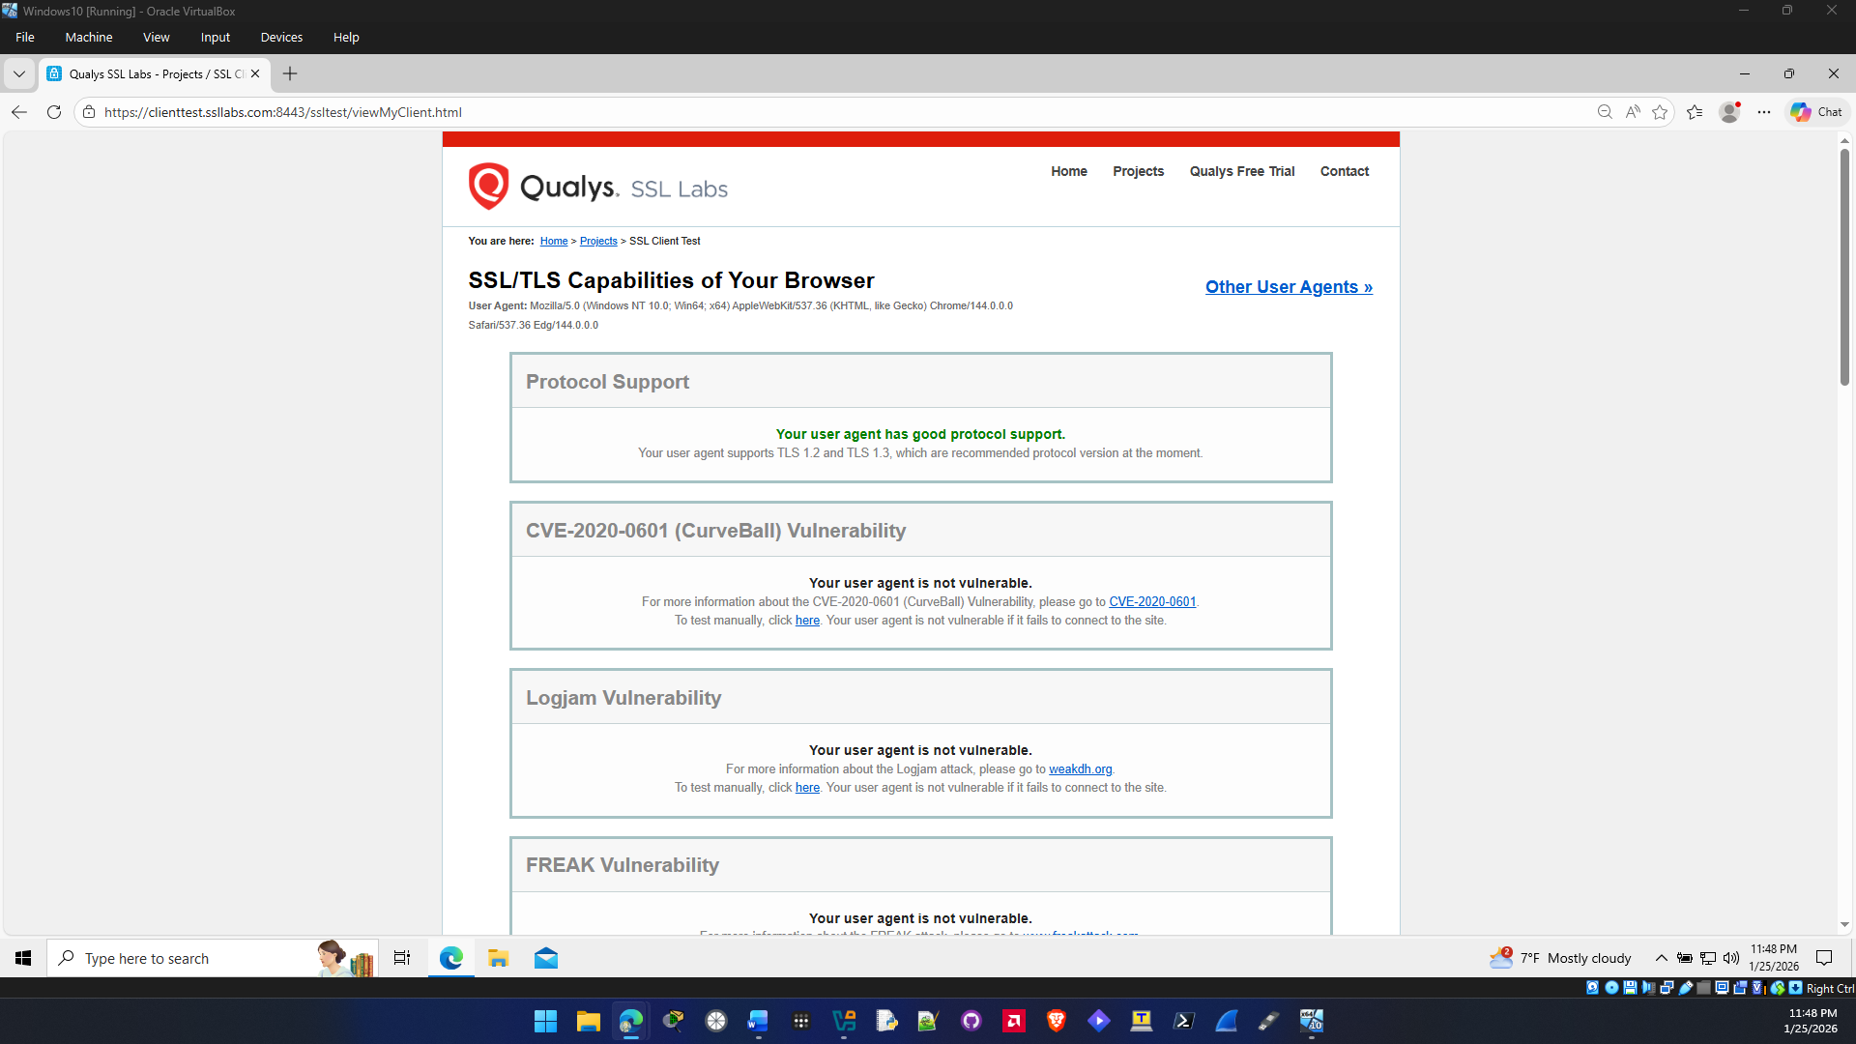
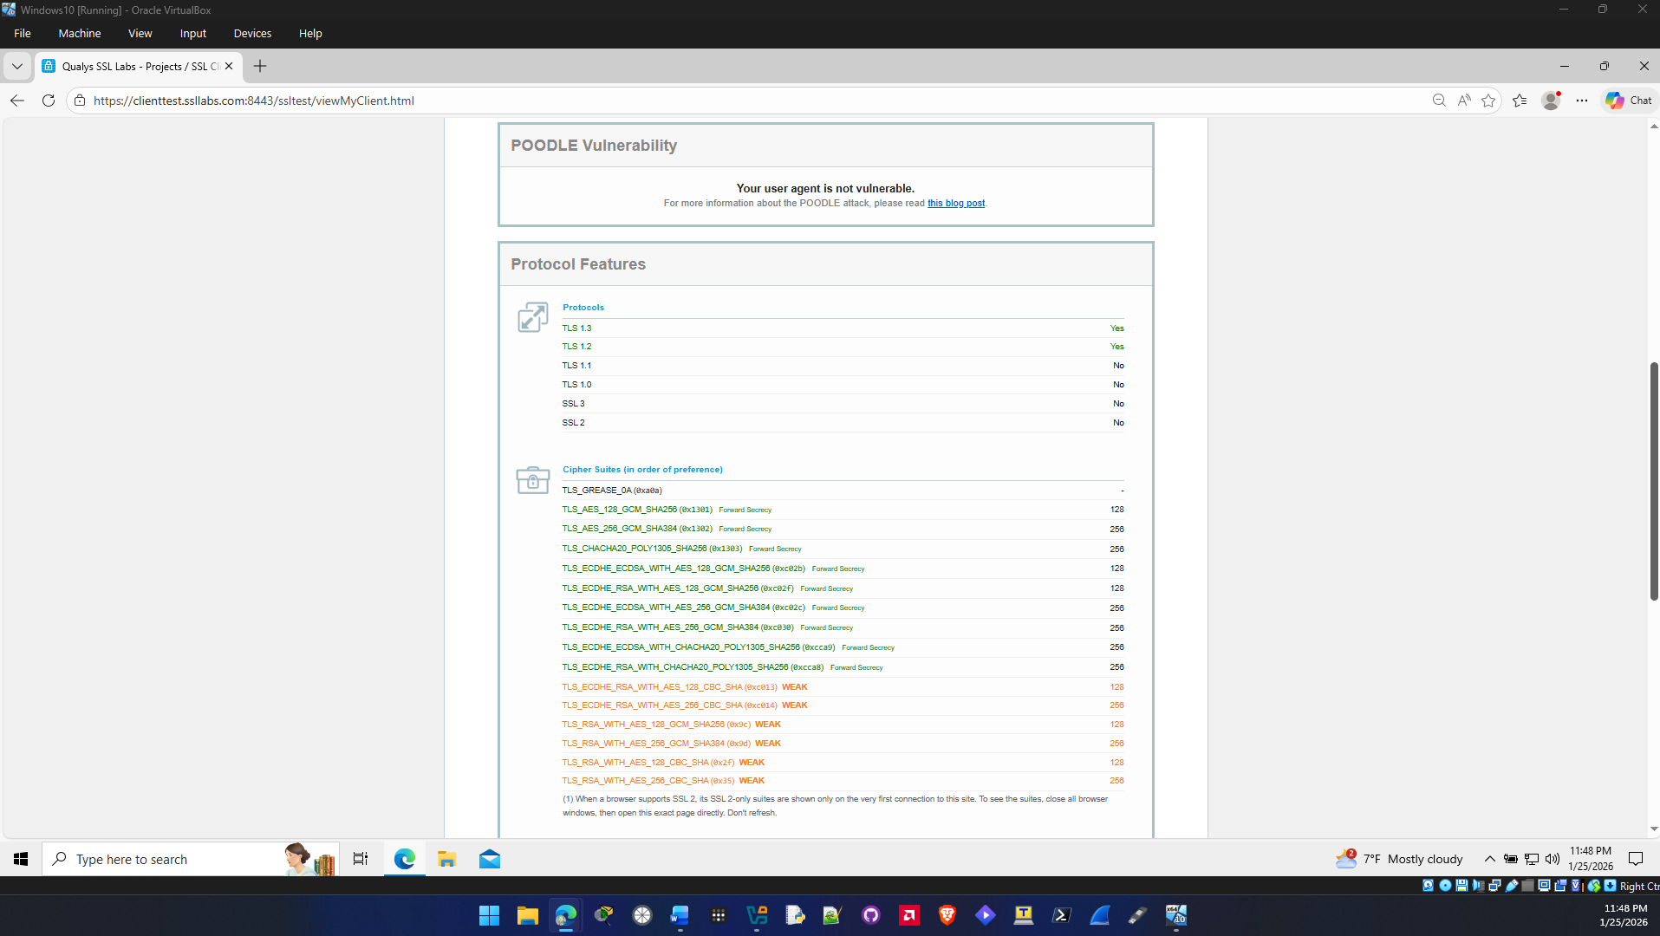
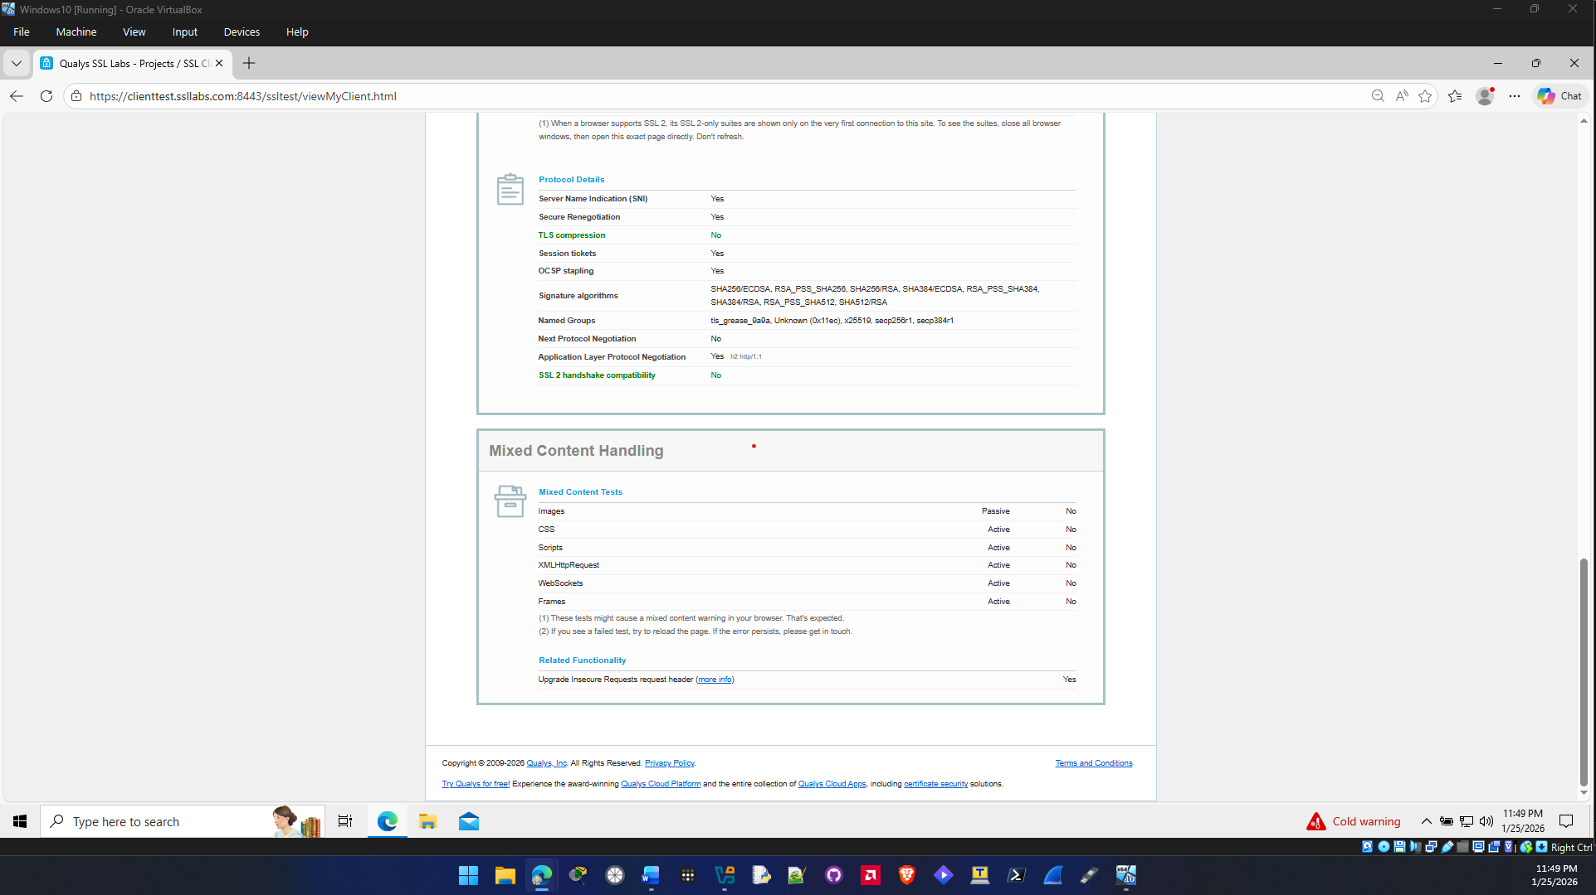

18: I used msedge for the first one and then Brave browser for the next one they both scored the same thing. This is because they are both popular browsers and up to date with the most recent protocols and security features.

